Mini project inno check

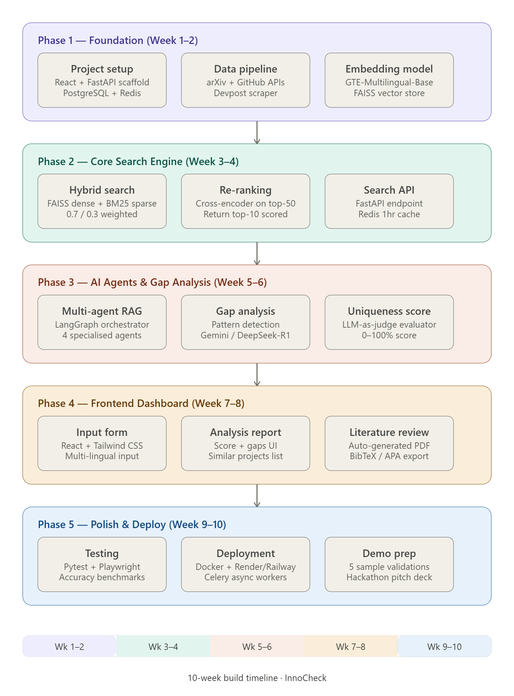

1.FastAPI

FastAPI ka use kahan hota hai?
FastAPI mainly in kaam ke liye use hota hai:
- REST APIs banana
→ Jaise login system, user data API, payment API
- Machine Learning models deploy karna
→ Model ko API bana ke use karna
- Backend development
→ Web apps ka server-side logic
- Microservices architecture
→ Chhote independent services banana

🔹 FastAPI kyun popular hai?
- ⚡ Bahut fast (NodeJS jaisa performance)
- 🧠 Easy to learn (Python based)
- 📄 Automatic documentation (Swagger UI)
- ✅ Data validation built-in

Simple words me:
Redis ka use hota hai:
- Data ko temporary store karne ke liye
- cache banane ke liye
- real-time applications me fast response dene ke liye

🔹 Redis ka full form
👉 REmote DIctionary Server

🔹 Redis kahan use hota hai?
- Caching 🧠
→ Database ke data ko temporarily store karke fast access
Example: frequently used data
- Session storage 👤
→ User login/session data store karna
- Real-time apps ⚡
→ Chat apps, live notifications
- Queue system / background jobs 📩
→ Tasks ko queue me rakhna (Celery ke saath)

Data pipeline = data ko collect → process → store → use karne ka flow

🧩 Typical flow:
- Extract → data lena (APIs, scraping)
- Transform → clean / filter / format
- Load → database / storage me save
👉 Isko ETL pipeline bhi bolte hain

🔹 2. arXiv + GitHub APIs ka use

📚 arXiv API
- Research papers fetch karne ke liye
- ML / AI topics pe latest papers
Example use:
- “LLM” ya “Computer Vision” ke papers fetch karna

💻 GitHub API
- Repositories ka data lena
- Stars, forks, trending projects
Example:
- Kisi paper ka related GitHub repo find karna

🔗 Combined use:
👉 Paper + code mapping system bana sakte ho
- arXiv → paper
- GitHub → implementation

Embedding Model kya hota hai?
Embedding model text ko numbers (vectors) me convert karta hai
👉 Example:
"AI is amazing" → [0.23, -0.91, 0.77, ...]

🧠 Use:
- Semantic search
- Recommendation
- Similarity detection

🔹 2. GTE-Multilingual-Base
Ye ek multilingual embedding model hai (Chinese + English + aur languages support karta hai)

🔹 Features:
- High-quality embeddings
- Multi-language support
- Retrieval tasks ke liye optimized

🔹 Use case:
- Hindi + English mix search 🔍
- Cross-language search (e.g. Hindi query → English doc)

🔹 3. FAISS Vector Store

📦 FAISS
FAISS ek library hai jo vectors ko store aur search karne ke liye use hoti hai

🔹 FAISS kya karta hai?
- Millions of vectors store karta hai
- Fast similarity search (nearest neighbors)
- Cosine similarity / L2 distance

🔹 4. Complete Flow (Important)

🎯 Semantic Search Pipeline:
- Text → Embedding (GTE model)
- Store → FAISS
- Query → embedding me convert
- Similar vectors → retrieve

🔗 Flow diagram:
Text Data → Embedding Model → Vector → FAISS Store
Query → Embedding → Similarity Search → Results

Hybrid Search kya hota hai?
👉 Hybrid search = Dense + Sparse search ka combination
- Dense (semantic) → meaning samajhta hai
- Sparse (keyword) → exact words match karta hai
👉 Dono ko combine karke best results milte hain

🔹 Components

1. Dense Search (Semantic)
- Embeddings (e.g. GTE-Multilingual-Base)
- Vector DB (e.g. FAISS)
👉 “AI model” ≈ “machine learning system” (similar meaning bhi match)

2. Sparse Search (Keyword)
- Algorithm: BM25
👉 Exact keyword match karta hai
Example:
- Query: “transformer model”
- Exact word presence important

🔹 Hybrid Search Flow
Query
├── Dense → FAISS → scores_d
└── Sparse → BM25 → scores_s
Final Score = (0.7 * dense) + (0.3 * sparse)

🔹 Weighted Combination (0.7 / 0.3)
👉 Tumne jo bola:
- 0.7 → Dense (semantic importance)
- 0.3 → Sparse (keyword importance)

📊 Formula:
final_score = 0.7 * dense_score + 0.3 * bm25_score

🔹 Re-ranking kya hota hai?
👉 Pehle:
- Hybrid search (FAISS + BM25) → top-50 candidates
👉 Phir:
- Cross-encoder model → in 50 ko deeply evaluate karta hai
👉 Finally:
- Best top-10 results return

🔹 Cross-Encoder kya karta hai?

🧠 Cross-Encoder
- Query + Document ko ek saath input deta hai
- True relevance score predict karta hai
👉 Dense model:
query → vector
doc → vector
(compare indirectly)
👉 Cross-encoder:
(query + doc) → directly score
👉 Isliye zyada accurate 🎯

🔹 Complete Pipeline
User Query
↓
Hybrid Search (FAISS + BM25)
↓
Top-50 Documents
↓
Cross-Encoder (Re-ranking)
↓
Top-10 Results (final)

